Advancement
SRS Document
For Smart

Version 1.1

Revision History
Date | Version | Description | Author
3/11/2011 | 1.0 | Initial version | Jim
3/15/2011 | 1.1 | Updated based on advices proposed in spec review meeting | Jim

Table of Contents

1. Introduction 4
1.1 Purpose 4
1.2 Scope 4
1.3 Overview 4
2. Specific Requirements 5
2.1 Student use case 5
2.1.1 Menus 5
2.1.2 EF Advancement Home 5
2.1.3 Hot Positions 7
2.1.4 Job detail 8
2.1.5 Skill builder & FAQs 9
2.2 Administrator use case 10
2.2.1 Menus 10
2.2.2 Upload Positions 10
2.2.3 Positions List 13
2.2.4 View Candidate 14
2.2.5 View Profiles 14
3. Release 15

Introduction

With the launching of EF Advancement short-term solution, a high volume of students have signed up for the program. Now it’s the time to enhance its functionalities to provide better services by offering job search and introducing administrator, whose mission is to pursue high student satisfaction response

Purpose
Create scalable solution for Job Posting and Application Process

Scope
- Students:
  - Registration, completion of Candidate Profile Form and “Welcome” message
  - Information updating on Login,
  - View, search and apply for jobs,
  - Access to “Skills Builder” content

- Administrators:
  - post, view, edit and manage new, existing and expiring jobs;
  - manage banner ads;
  - notified when students apply for jobs;
  - create, upload and edit all student information;
  - search data fields

Overview
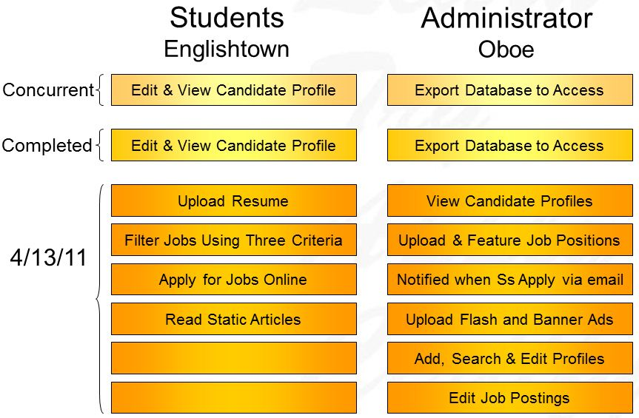

Specific Requirements

Student use case

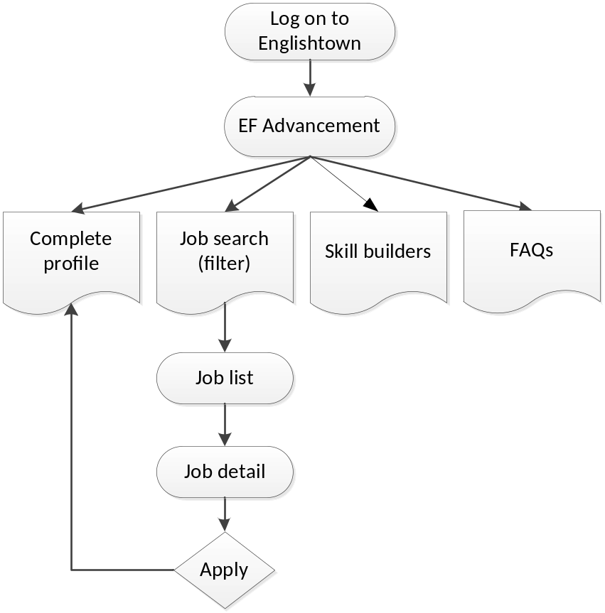

Menus

- EF Advancement Home
- Hot Positions
- My Profile
- Skill Builders
- FAQs

EF Advancement Home


A
B
C
D
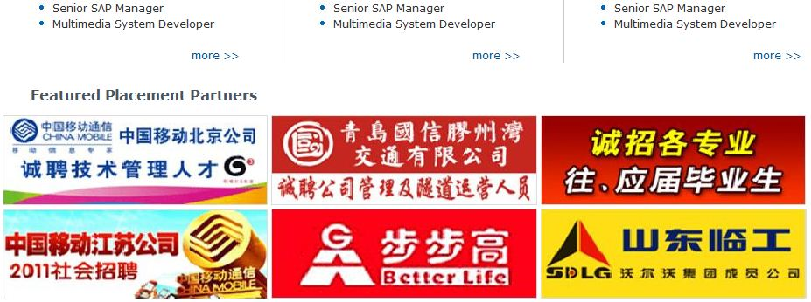
E

Page explanation
A | Big banner, updated from http://umbraco.englishtown.com/
B | Randomly get 5 hot positions from hot position pool (see 3.2.3 below how to create the pool), each is showed with full title and fore 30 characters from description, linking to job detail
C | Job search area, for now, it contains 3 filters: location, industry and minimum language level (refer to 3.2.2 below). They can be functioning either as a single criteria or combined together. Result is listed on position list page
D | Positions in Beijing/Shanghai/Guangdong Area, display the job title of top 5 most-recent in each region. ‘More’ links bring users to job list
E | Featured placement partners, updated from http://umbraco.englishtown.com/

Hot Positions
A
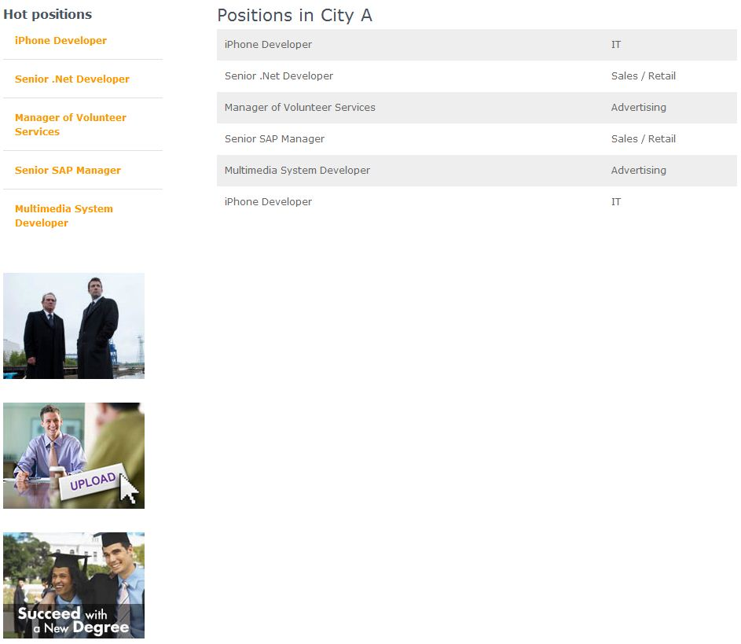
B
C

Page explanation
A | Randomly get 5 hot positions from hot position pool, each is showed with full title, linking to job detail
B | - List 20 records per page  - Column names: title, location, industry, minimum language level, date posted  - Order by date posted, from latest to earliest  - Title is linked to job detail
C | Pic banner, updated from http://umbraco.englishtown.com/

Job detail

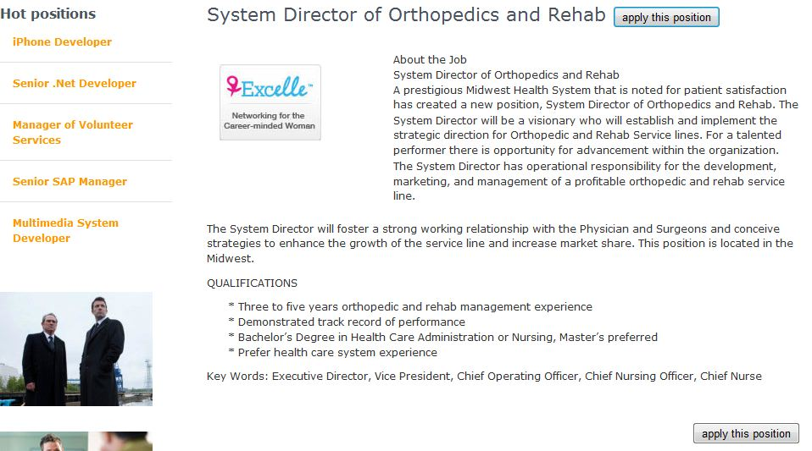
A
B

Page explanation
A | Larger letter: title and description  Smaller letter: location, industry & minimum language level
B | ‘Apply Now’, an email notification is sent to administrator (EF.Advancement@ef.com, need to update the contact link in nav as well, which currently is cs.advancement@ef.com )  Subject: {center} - {Chinese name}/{English name} applied for {position title}  Body: student profile view, with edit link to profile edit page in OBOE  If the student hasn’t complete personal profile, the ‘Apply Now’ button click will pop up an alert window:  Please complete your personal profile before applying for any position. (blurb id = )  A button named ‘Do it now’ below the text, clicking it to open the profile page in a new page  After successful submitting, replace the button with text of ‘Position applied on {date, 2011-3-15}’, next time the same student checks the position, still the text, no button

Skill builder & FAQs

Supported by http://umbraco.englishtown.com/

Administrator use case

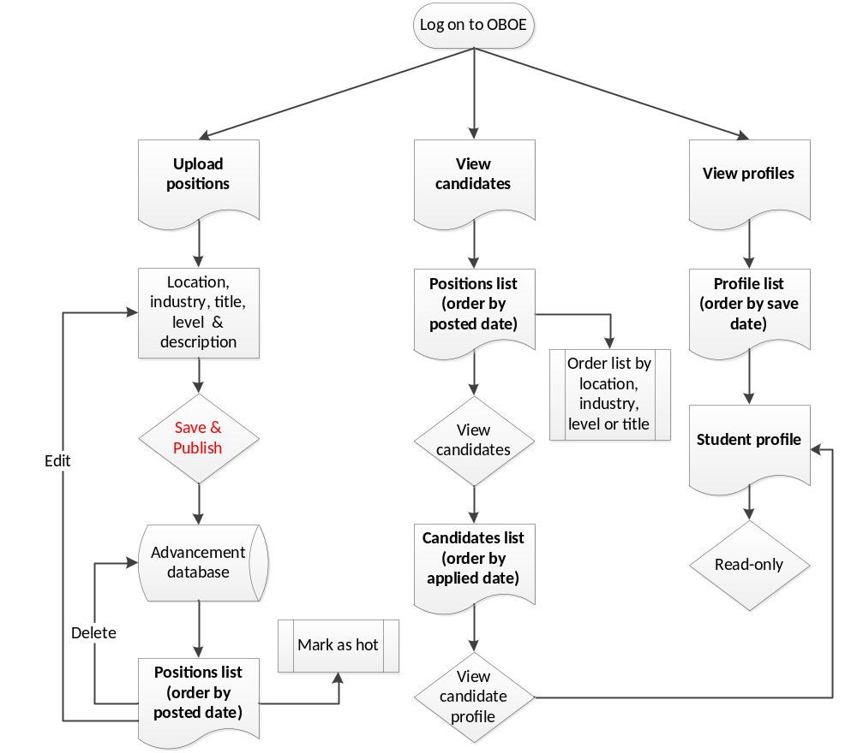

Menus
Add a new tab into the navigation bar on the left side of OBOE
- EF Advancement
  - Upload Positions
  - View Candidates
  - View Profiles

Upload Positions
Position form

* Position title (max 30 characters)

* Location □ Beijing □ Shanghai □ Guangzhou □ Shenzhen □ Other
│▼
* Industry
│▼
* Min Language Level

* Description
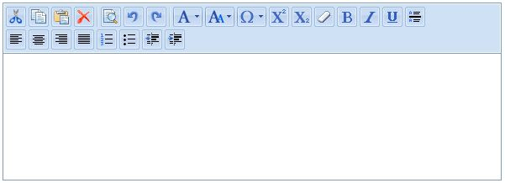
(max 20000 characters)
Save & Publish

- Position title, max 30 characters
- Location, checkbox
- Industry, dropdown list

  - P.R.
  - Logistics
  - Finance
  - Medical
  - Telecom
  - Advertising
  - H.R.
  - Arts
  - Marketing
  - Raw material
  - I.T.
  - Trading
  - Publishing
  - Education
  - Legal
  - Real estate
  - Media
  - Other

New, need to replace corresponding part on student profile page

New fields | Old ones
Accounting/Auditing
Administrative/Support Services
Agriculture
Architecture
Business Development
Construction
Consulting
Creative/ Design/Multimedia
Customer Service
Engineering
Event Planning
Finance | Finance
Fundraising/Development/Charitable
Government
Healthcare /Health Services | Medical
Hotel/Hospitality
Human Resources
Information Management / I.T. | I.T.
International Trade/Business
Journalism
Law
Library Science
Management
Manufacturing
Marketing/Advertising/P.R. | P.R. & Advertising
Operations
Production | Raw Material
Project Management
Research/Research and Development
Retail/Merchandising
Risk Management
Sales | Sales
Supply Chain Management/Logistics | Logistics
Teaching/Education/Training
Telecom
Translation
Other

- Min Language level
  - Beginner
  - Elementary
  - Intermediate
  - Upper – Intermediate
  - Advanced / Upper – Advanced
For example: a student chooses to filter Beginner: he will only get results showing jobs specified as Beginner English. A student who chooses to filter for Intermediate will get results for Beginner, Elementary and Intermediate, but he WON’T get results for Upper-Intermediate, Advanced or Upper-Advanced. However, all students should be able to apply for positions of any Language Level, regardless of their level.
- Description, rich text box, max 20000 characters, image link is supported

All fields are must-haves, save & publish will redirect page to job list

Positions List

Mark as hot positions

Position title ▲▼ | Location ▲▼ | Industry ▲▼ | Language level ▲▼ | Date posted ▲▼ | Operation
□ Service Process Engineer Beijing I.T. Beginner 2011-3-11 Edit Delete View Candidates
□ Korean Online Customer
Relations Associate Shanghai Education Elementary 2011-3-11 Edit Delete View Candidates
□ Salesforce Development
Manager Beijing/Guangzhou P.R. Advanced 2011-3-11 Edit Delete View Candidates
□ Business Analyst Shenzhen Finance Beginner 2011-3-11 Edit Delete View Candidates
□ Korean Online Customer
Relations Associate Shanghai Education Elementary 2011-3-11 Edit Delete View Candidates
□ Salesforce Development
Manager Beijing/Guangzhou P.R. Advanced 2011-3-11 Edit Delete View Candidates
□ Service Process Engineer Shenzhen I.T. Beginner 2011-3-11 Edit Delete View Candidates
□ Korean Online Customer
Relations Associate Shanghai Education Elementary 2011-3-11 Edit Delete View Candidates
□ Salesforce Development
Manager Beijing/Guangzhou P.R. Advanced 2011-3-11 Edit Delete View Candidates

Mark as hot positions

- List 20 records per page
- By default, order the list by date posted, latest to earliest
- Click ▲(ascent)▼(descent) beside each title to reorder the list alphabetically
- Operation
  - Edit, move back to position form (refer to 3.2.2 above)
  - Delete, remove the position from the list (do not physically delete it, mark it as overdue in database)
  - View candidates, refer to 3.2.4 below
- Position title link works the same as edit link
- Create hot position pool. Select some classes by ticking the checkbox, and press the button ‘mark as hot positions’ to make them randomly appear on student pages (see 3.1 above), jobs posted 3-month ago will be phased out from the pool

View Candidate

Position: Service Process Engineer
Chinese name ▲▼|English name▲▼|Center ▲▼|Elite card # ▲▼ |Language level ▲▼ |Date applied ▲▼| Operation
范新意 Idea Fan BJGM1 BJ0001 Beginner 2011-3-11 Delete
宋秀玲 Ring Song SHPSQ SH0001 Advanced 2011-3-11 Delete
戴盼盼 Hope Dai GZTHB GZ0001 Intermediate 2011-3-11 Delete
刘静 Silence Liu SZDWG SZ0001 Upper-intermediate 2011-3-11 Delete
王强 Strong Wang BJFXM BJ0002 Beginner 2011-3-11 Delete
徐晓玲 Ring Xu SHZSP SH0002 Elementary 2011-3-11 Delete
许松柏 Bai Xu GZTJR GZ0002 Upper-advanced 2011-3-11 Delete

- List 20 records per page
- By default, order the list by date applied, latest to earliest
- Click ▲(ascent)▼(descent) beside each title to reorder the list alphabetically
- Click Chinese/English name link to go to student profile page (currently online http://e1.englishtown.com/school/efadvancement ). Permission: read-only
- Delete, the student won’t be shown on candidate list, but his/her profile remains available

View Profiles

Student Profile List
Chinese name ▲▼| English name▲▼| Center ▲▼ | Elite card # ▲▼ | Language level ▲▼ | Date saved/updated ▲▼
范新意 Idea Fan BJGM1 BJ0001 Beginner 2011-3-11
宋秀玲 Ring Song SHPSQ SH0001 Advanced 2011-3-11
戴盼盼 Hope Dai GZTHB GZ0001 Intermediate 2011-3-11
刘静 Silence Liu SZDWG SZ0001 Upper-intermediate 2011-3-11
王强 Strong Wang BJFXM BJ0002 Beginner 2011-3-11
徐晓玲 Ring Xu SHZSP SH0002 Elementary 2011-3-11
许松柏 Bai Xu GZTJR GZ0002 Upper-advanced 2011-3-11

- List 20 records per page
- By default, order the list by date saved/updated, latest to earliest
- Click ▲(ascent)▼(descent) beside each title to reorder the list alphabetically
- Click Chinese/English name link to go to student profile page (currently online http://e1.englishtown.com/school/efadvancement ). Permission: read-only

Release

- For all centers
- Expected release date: 2011-4-13

